**MOBILE STORE**

**A**

Project Work

Submitted as Major Project in Bachelor of Engineering

Submitted to

## RAJIV GANDHI PROUDYOGIKI VISHWAVIDYALAYA BHOPAL (M.P)



Submitted By

**Neelesh jhariya(0105CS111056)**

**Nidhi Nikose(0105CS111059)**

Under the Guidance of

Prof. Shreeja Nair

## (Department of Computer Science & Engineering)



DEPARTMENT OF COMPUTER SCIENCE & ENGINEERING

**JUNE-2015**



***CERTIFICATE***

This is to certify that the project entitled **“MOBILE STORE”** being submitted by Nidhi Nikose,Neelesh Jhariya Student of **8th**  Semester,in Computer Science & Engineering have done their work as MAJOR PROJECT for Partial fulfillment of the degree from RGPV, Bhopal (M.P.) is a record of bonafide work carried out by them under our supervision.

###### Prof. Shreeja Nair Prof. Amit Shrivastava

###### **Guide Head**

###### **Department of Computer Department of computer**

**Science & Engineering Science & Engineering**

###### Prof Monika Agrawal/ Prof. Anubha Prajapati

###### **Project Coordinators**

**Acknowledgement**

We would like to place on record my deep sense of gratitude to **Prof. Shreeja Nair** Dept. of Computer Science Engineering OIST Bhopal , for his generous guidance, help and useful suggestions.

We express my sincere gratitude to **Prof. Amit Shrivastava,HOD Dept. of Computer Science Engineering, OIST Bhopal**, for his stimulating guidance, continuous encouragement and supervision throughout the course of present work.

We also wish to extend my thanks to **Prof. Monika Agrawal & Prof. Anubha Prajapati, Project Coordinato**r and other colleagues for attending my seminars and for their insightful comments and constructive suggestions to improve the quality of this project work.

We are extremely thankful to **Dr. V.K.Sahu, Director OIST Bhopal** for providing me infrastructural facilities to work in, without which this work would not have been possibl

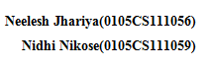

**Table of Contents**

* **LIST OF FIGURES………………………………………………….…………5**
* **INTRODUCTION…………………………………………………….………..7**
* **BACKGROUND AND LITERATURE SURVEY…………………….……..10**
* **REQUIREMENT ANALYSIS………………………………………………..18**
* **PROCESS MODEL…………………………………………………….……..34**
* **TECHNICAL DETAILS………………………………………………..…….38**
* **TABLES & SYSTEM DESIGN………………………………………………40**
* **TESTING……………………………………………………………………...45**
* **SCREEN LAYOUTS……………………………………………….…………48**
* **FUTURE ENHANCEMENTS…………………………………….………….53**
* **CONCLUSION…………………………………………………….………….55**
* **REFERENCES…est………………………………………………….…………..57**
* **BIBLIOGRAPHY………………………………………………….………….57**

**List of figures**

|  |  |  |
| --- | --- | --- |
| **S.No** | **Figure** | **Page** |
| **1** | **Use case diagrams** |  |
| 1.1 | Custumer | 24 |
| 1.2 | Admin | 25 |
| **2** | **Activity Diagram** |  |
| 2.1 | Custumer applies for registration | 26 |
| 2.2 | Custumer submits request/feedback | 27 |
| **3** | **Sequence Diagram** |  |
| 3.1 | Generic login system | 28 |
| 3.2 | Retrival of messages | 29 |
| 3.3 | Attendace registering | 30 |
| 3.4 | Feedback creation and filling | 31 |
| **4** | **Class diagram** | **32** |
| **5** | **Component** **diagram** | **33** |
| **6** | **Deployment diagram** | **33** |
| **7** | **Agile Methodology** | **35** |

### 

### ABSTRACT

### Mobile Store is an Online Shopping system specifically made to cater the needs of a mobile shops or similar product business.

### It provides various features that will enhance the productivity of shopping experience.

### It focuses on various products,shipments,delivery,catalogue and payments releted issues in an innovative and time saving way providing business management full control and ease over the process.

### Mobile Store system is made in such a way that it can extend with the needs of the business.

### Its core API and interfaces are smartly designed keeping in mind the ever changing scenario of modern business scenario.

### Mobile Store system will help business to manage their shops, keep their services available at fingertips for customers and making everything possible with minimum human effort.

### 

### Chapter 1

### Introduction

It is known globally that, in today’s market, it is extremely difficult to start a new smallscale Business like mobile store and its sustenance with competition from the well-established and settled/brand owners.custumer need a dedicated system for only mobile there are huge range of mobile in todays decade and there are lots of features in mobiles which attract the custumer over project is provide mobile online user can pay and buy from every where through internet Most often, even if the quality of the mobile is really good, due to a lack of advertisement or business at the small scale, it just becomes another face in the sea, and the mobile does not reach a larger group of customers. In fast paced life of today when everyone issqueezed for time, the majority of people are finicky when it comes to doing physical shopping.Logistically, a consumer finds a mobile more interesting and attractive when they find it on the website of a retailer directly and are able to see item’s details online.The customers of today are not only attracted because online shopping is very convenient, but also because they have broader selections, highly competitive prices, better information about the mobile (including people’s reviews) and extremely simplified navigation for searching regarding the mobile.Moreover, business owners often offer online shopping options at low rates because the overheadexpenses in opening and running a physical store are higher. Further, with online shopping, their mobiles have access to a worldwide market, which increases the number of customers from different ethnic groups, adds customer value, and overall sustainable in the marketing. Online web stores, such as Amazon and eBay, have gained huge popularity over the years because one can buy almost everything at these stores. These web stores also give an opportunity a lot of small-scale companies and manufactures to reach the global market and to directly sell their mobiles to people without involving different other companies or middlemen before their mobile can reach the shelves of a physical store. Further, instead of using the available platforms, manufacturers can bring a concept of designing their own web store to sell their mobiles directly to the masses.

**Literature Review**

The history of ecommerce shopping began immediately after the World Wide Web, or WWW, became a major medium to communicate information around the world. Ecommerce shopping-cart applications allow consumers to buy goods or services directly over the internet using a web browser. This online shopping evokes the business-to-consumer (B2C) process where a consumer buys directly from the business. The process where a business buys from another business is called a business-to-business (B2B) process. The best examples of shopping cart applications using B2B process are eBay and Amazon, both of which were launched in 1995. At present, most users of these online shopping-cart applications are people who have higher levels of education, have exposure to technological advancements, and are in a better income group. Such users develop a positive attitude towards these convenient shopping techniques.According to a study in December 2011, Equation Research surveyed 1,500 online shoppers and found that 87% of tablet owners made online transactions during the early shopping season.Building a new successful shopping cart is simple because of high competition

### 1.1 ProblemStatement there is glloblization of e-mobile business because all over the world every one use internate before purches they search about the mobile on internet they do not want to wast there time they can pay for mobile from every where they can choose their mobile according to their choice they get discount offer in e-commerce application because directly purches from mobileion company (1) Information about any user is not available on the hand if somebody wants to access it.

### (2) before e-commerce application user payment process is slow. (3) User have not number of choose of mobile. (4) oder maintainance is really though in existing system. Inspite of all the efforts, It leads of inaccuracy. A number of cases are brought to notice when user complaint about their oder being unresonably less in records. (5) Accounts information is not centrally available which leads to confusion and repetetive work at the time of shiping. Also there is not any notification system for User to know if they have any dues pending. (6) Taking feedbacks is almost impossible these days. Doing it manually and then reading the feedbacks is really messy and time-consuming job. It also leads to inaccurate results of feedback and somtimes bad consequences.

### Business organization needs a software system that can manage all their complications easily and management authorities can focus on real-improvement rather than taking decisions on the basis of assumptions. A online system will lead institute towards better management,better understanding and finally many folds better perforance.

**1.2 Aim:**Our aim is to provide a better technological solution to the business to manage its existing work and data-load. We will be constructing an online system that will manage all the mobile's data, key feature,type ,prize,images and its statistics and a messaging based interaction environment between user and higher management.

### Also our efforts will be to make sure that system is capable of expanding itself in future so that further extensions and modifications can be done in it depending upon the growing needs of the business organization.

### 

**CHAPTER 2**

**BACKGROUND AND LITERATURE SURVEY**

**2.1 Study of current system**In the current system we analysed and inspected and finally extracted these 8 problem points. Our solution will address these problems and further improvements into the system will be based on these core problem points and its solution implementation.

(1) Mobile's data management  
(2) User transaction detail  
(3) User needs  
(4) user requests/complaints/feedbacks {no-record}  
(5) communication with higher authorities and its record keeping  
(6) User level feedbacks and its records  
(7) collection of mobiles  
(8) easy transaction from any where

We analysed the whole system and we saw that these are the key factors and stack holding pillers in the informational infrastructure of the institute. In order to improve the quality and standard of the system we will have to improve upon the speed,ease accuracy and feasibility of these processes.

We took each of these factors one by one and studied the current process being followed in the business organization to achieve these tasks. We found many flaws in the current system and saw scope of improvements in various aspects. In the next excerpts we are giving the detailed study of the current process being folloowed in the system, the problems associated with current procedures and our proposed solution.

**2.1.1 User data management  
Current Process**Every transaction user registration is done. In user registration process user fill an offline custumer's registration form. In this form user fill some old and some new details. The filled user form is undergone a manual process of revalidation/recheck by authority. As a proof of transaction user needs to show his/her transaction reciepts to the concerned registeration authority. At this point there is no any live communication between the user and authority department is present and registration solely depends upon the fee-transaction paper proof.  
After registration process a big pile of user registration form is collected and is kept under scruitiny for the whole semester under any specific supervision.  
What is in the form: (information and its content weightage)   
New pictures - 10%  
Contact details - 10%  
existing details - 50%  
feedback about site and organization - 30%  
Above mentioned 30% existing details about user(which are not liable to change throughout the cource - viz Name,oder number,prize Home address) are refilled and revalidated again. This leads to wastage of time,effort and storage.

**Problem in it**

First major problem around this issue is the cost involved in it. There is cost involved in of capital it is very simple process to user they can order a mobile and pay online or of line in other hand there are many problem in manual payment in this process user can order form every where using this appilication less employee paument .An average employee getting 30,000/- per month means rs 166/- per hour, is kept busy for hours in maintaining and compiling the stuff which should be totally automatic.

This also waste total system time.Repeted information is collected in the system and practically there is no way to get rid of it.Inspite of all the efforts being done to ensure the process being easy, the major concern here is that the custumer data is not centrally avilable.

**Access and availability**

Process,Storage and Retrival all the three important factors are very slow in the current system. We need to address the issue in such a way that information is processed,stored and respectively formattedwithout any manual effort,on the click of few buttons and all the time available. We also need to ensure that information is secured and authenticated to the latest as possible.  
**Proposed Solution**.

These applications are designed for industrial purposes to generate revenue by providing these applications to customers looking to launch a website for their respective businesses.

The application proposed in this paper is more focused on developing a simple, yet complete,

application specifically designed for computer science students to learn the basics about

application design and development. This application performs all the basic functions that the

above-mentioned applications do, such as selecting an item and adding it to the shopping cart,

user login or registering, checkout of the item, etc. Other functions that can be added to this

application are proposed in the future work, and they would be necessary under a more complete

**CHAPTER 3**

**REQUIREMENT ANALYSIS**

**3 Requirement Specification**

**3.3.1 Functional Requirements**

This section contains the requirements for the online shopping-cart application. The

functional requirements, as collected from the users, have been categorized as follows to support

the types of user interactions that the system shall have.

1. **Educational Purpose:** The main purpose of this online shopping-cart application is to teach

computer science students the basics of the Java, JavaScript, and HTML programming

languages along with the concepts of web-application designing.

• **FR01:** The students shall be able to view the source code for the entire application.

• **FR02:** The students shall be able to, individually, view and understand the code for all

pieces on the UI.

• **FR03:** The students shall be able to debug the application’s source code using Firebug,

which is an online tool to inspect, edit, and monitor HTML, CSS, and JavaScript requests

directly on the web page.

2. **User: View Categories and Items:** The users shall be able to see the home page of the

online shopping-cart application when they first run the program. The users shall be able to

view the different categories, select categories, browse through the items in each category,

and add items to the shopping cart. The users shall be able to view the shopping cart and

more information about each item.

• **FR04:** The users shall be able to view the categories on the application’s home page.

• **FR05:** The users shall be able to view items in different categories.

• **FR06:** The users shall be able add items to the cart.

• **FR07:** The users shall be able to view more information about an item before adding it to

the cart.

• **FR08:** The users shall be able to able view the shopping cart.

• **FR09:** The users shall be able to browse through the available items.

3. **User: View Shopping Cart:** After the first run of the application, the users shall be able to

see their designated home page. After browsing through the items and adding items to the

shopping cart, the users should be able to view the items in the shopping cart. The users shall

be able to check out or continue shopping. The users shall be able to delete items from the

cart.

• **FR010:** The users shall be able to view the items added to the cart.

• **FR011:** The users shall be able to check out with the current items in the cart.

• **FR012:** The users shall be able to continue shopping.

• **FR013:** The users shall be able to delete items from the cart.

4. **User: Checkout Items**

• **FR014:** The users shall be able to check out items only when there are items in the

shopping cart.

5. **Login/ User Authentication**

• **FR015:** The users shall login or register using the user authentication form.

• **FR016:** The users shall not login or register if the information is incomplete or invalid.

6. **User: Place Order**

• **FR017:** The users shall place an order by completing the information in the order form.

• **FR018:** The users shall not be able to place an order if the information in the order form

is invalid or incomplete.

7. **Admin: View User Information**

• **FR019:** The administrator shall be able to view all the users’ information that completes

the order form and the checkout process.

8. **Admin: Add/Update/Delete Shopping Items**

• **FR020:** The administrator shall be able to add new items to the list of shopping items.

• **FR021:** The administrator shall be able to modify/update an item’s price and description.

• **FR022:** The administrator shall be able to delete items from the main page of the

shopping-cart application.

**Additional Functional Requirements**

• **FR023**: The administrator shall be able to view the entire history of the checked-out

items.

• **FR024:** The administrator shall be able to view the entire history for the users who

successfully complete the checkout process

**Web Client:**

It should be accesible through any common web browser following w3c standards.

**Authentication:**

Different type of users should be assigned different authentication levels according to the task and rights assigned to them.A proper rights management should be maintained.

**Communication system:**

Communication system should be there which can help different users communicate in

text based media i.e. message between their working hierarchy.

**6**. **Extendability**System should be so made that it can be extended and tailored according to the changing needs of the organization.

**Performance Requirements**

This section lists the performance requirements expected from the online shopping-cart

application.

1. **PR01:** The users shall be able to add an item to the cart in fewer than 5 seconds.

2. **PR02:** The users shall be able to view information about an item in fewer than 5 seconds.

3. **PR03:** The users shall be able to check out the items in the shopping cart within 10 seconds

after completing the order form.

4. **PR04:** The navigation between pages shall take fewer than 5 seconds.

5. **PR05:** The application shall be able to do a validation check on the information provided in

the user-authentication form and the place-order form to avoid false or incomplete

information.

**3.3.2 Non Functional Requirements**

**1. High Performance:**  
System should be able to handle hight amount of load on normal and peak times,it should be able to deliver high performance and high data availability.

**2. High availability:**   
System should be able to remain up and runnig always no matter how much load its bearing. It should be able to protect itself from any error in case of high demand and fatigue.  
**3. Secure:**  
System should be highly secure as in terms its dealing with private data of an institute. Data is always crucial and it should be protected at any cost.  
**4. Regular backup facility:**System should be able to backup all the data at regular intervals. In case of any disaster it should be able to restore its backup without delay providing user a continuous undisturbed experience.  
**5.Modular Architecture:**  
Change is the key to growth of an organization and this system should be made modular so that it can adapt to that changing demands. Modules could be added to it and could be edited on defined rules.

**3.4 Identify Users**

The users of the online shopping-cart application, based on their roles, are customers (users) and the administrator (owner). These users are identified based on their experience and technical expertise.

1. **Admin:** The administrator is the owner of this online shopping-cart application. One must

have a basic understanding of computers and the internet as well as prior knowledge for

operating the eclipse and Java programming languages. The administrator is responsible for maintaining all the training documents required for the system. The administrator can perform the following functions:

• Assign or change the price of the items, update the items in the list, and delete the items.

• Assign sales tax for different states at the time of checkout.

• View the history of the customers who purchased the items.

2. **Users:** The users of this online shopping-cart application are all customers who would shop

to test the application. These users are anyone with shopping experience and the know-how

to browse through a shopping-cart application. They must have basic understandings about

computers and the internet. The users should be able to perform the following functions

using this system:

• View, browse, and select a category on the home page.

• View, add, and update items in the cart.

• Delete items from the cart.

• Check out the items from the application or continue shopping.

• Sign-on/login using a username and password.

• Place the order by completing the order form. **3.4.5 Other Authorities**  
other management personal come under other authorizes. They are provided with general features of report viewing and notice posting. In case of any customization, exisint modules will be tailored to meet particular requirements.

**3.5 Feasibility Study  
3.5.1 Time feasibility**We are planning to divide the whole system work into 24 sprints(3 sprints per module). Each sprint will be producing a working module which we can directly deploy on the servers. Although we preent any use of incomplete system unless until the finall load testing of complete system is not done.We will be able to complete the implementation phase in next 6 months of time.  
**3.5.2 Technical feasibility**  
All the technologies required to implement this system are currently existing in the market. There is no need to do special research and development to invent the implementation platforms.We will be usingfollowing technologies of web development to implement our solution:  
**(1)PHP**   
PHP is a server-side scripting language designed for web development but also used as a general purpose programming language. As of January 2013, PHP was installed on more than 240 million websites (39% of those sampled) and 2.1 million web servers. Originally created by Rasmus Lerdorf in 1994, the refer ence implementation of PHP (powered by the Zend Engine) is now produced by The PHP Group. While PHP originally stood for Personal Home Page, it now stands for PHP: Hypertext Preprocessor, which is a recursive .  
**(2)Codeigniter**CodeIgniter is an open source rapid development web application framework, for use in building dynamic web sites with PHP. The first public version of CodeIgniter was released on February 28, 2006, and the latest stable version 2.2.0 was released June 5, 2014.

CodeIgniter is loosely based on the popular Model-View-Controller development pattern. While view and controller classes are a necessary part of development under CodeIgniter, models are optional.

CodeIgniter is most often noted for its speed when compared to other PHP frameworks. In a critical take on PHP frameworks in general, PHP creator Rasmus Lerdorf spoke at frOSCon in August 2008, noting that he liked CodeIgniter "because it is faster, lighter and the least like a framework.".

**(3)MySQL**  
MySQL is an open source RDBMS that relies on SQL for processing the data in the database. MySQL provides APIs for the languages C, C++, Eiffel, Java, Perl, PHP and Python. In addition, OLE DB and ODBC providers exist for MySQL data connection in the Microsoft environment. A MySQL .NET Native Provider is also available, which allows native MySQL to .NET access without the need for OLE DB. MySQL is most commonly used for Web applications and for embedded applications and has become a popular alternative to proprietary database systems because of its speed and reliability. MySQL can run on UNIX, Windows and Mac OS. MySQL is developed, supported and marketed by MySQL AB. The database is available for free under the terms of the GNU General Public License (GPL) or for a fee to those who do not wish to be bound by the terms of the GPL.

**(4)Bootstrap**Bootstrap is the most popular HTML, CSS, and JS framework for developing responsive, mobile first projects on the web.Bootstrap makes front-end web development faster and easier. It's made for folks of all skill levels, devices of all shapes, and projects of all sizesBootstrap easily and efficiently scales your websites and applications with a single code base, from phones to tablets to desktops with CSS media queries.Bootstrap is open source. It's hosted, developed, and maintained on GitHub.Millions of amazing sites across the web are being built with Bootstrap.  
**3.5.3Economic feasibility**This project will be economically possible because its completely built under open source technologies. Using open source tehnologies reduces cost of project as open source technologies are free of cost and are competitively used in developing high performance solutions. We are using agile development methologies which will make the building of this big software easy and systematic.   
**3.5.4Legal feasibility**This project is being developed using Open Source technologies which makes us legally free of any licensing cost. Adantage of using open source technologies is that we can focus more on technical aspect of our project without worrying about the legal aspects of using the technology.  
**3.5.5 Operational feasibility**We will be developing this system on personal laptops(4gb RAM,Intel 2.5 GHz) machines.

The system will be deployed on a RedHAT 7 Linux Server being operated in institute. It contains 8gb RAM and 16 cores of 2.5 GHz processors. The whole serer is backed up with 1 TB of SATA 1.5 Stoarage disks. Regular backup of whole database is taken manually each satarday. This configuration is more than enough to serve 1000 users at a time for a web application. We are confident that our system will run healthy on such configuration.   
**3.5.6 Social feasibility**As a proof of trust this system will be deployed on fake data for some time and automated tests will be performed on it. If system runs fine and is able to pass all the benchmarks and criteria defined by our evaluation team then it will be fit to deploy in the institute premices.

**3.6 Object Oriented Analysis Modeling  
3.6.1 Use case diagrams**

The system’s use case shows the user a detailed view of the system and how the actors

would interact with each other and with the system. The explanation for each use case is then

provided below the system use case for the administrator (Figure 1) and the user (Figure 2),

helping the user to understand who are the actors areas as well as giving the description for each

use case along with its pre- and post-conditions that should be satisfied once the use case is

implemented in the software.

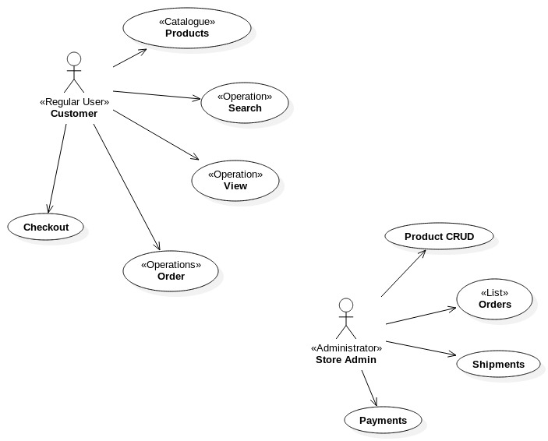

**3.6.2 Activity diagrams  
Activity** This section lists the activity diagram and describes the flow of activities in the system. A

detailed description is then given after the figure for each activity. Figure 3 provides the

overview of the activity of mobile storeapplication.**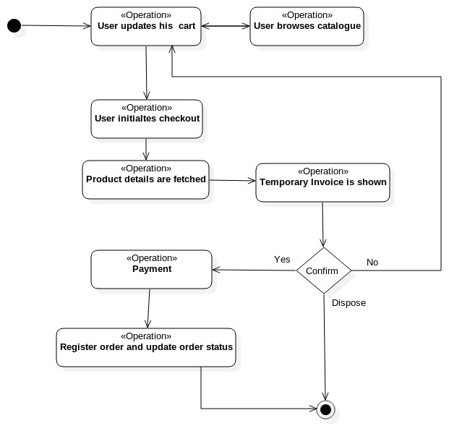 Custumer Applies for registration**

**3.6.3 Sequence diagrams  
(1) Generic Login System**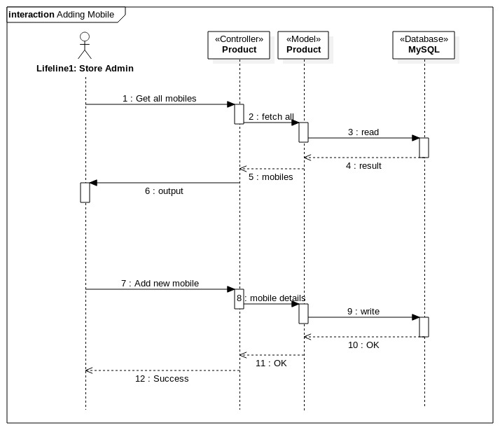

**(2)Retrival of messages  
  
  
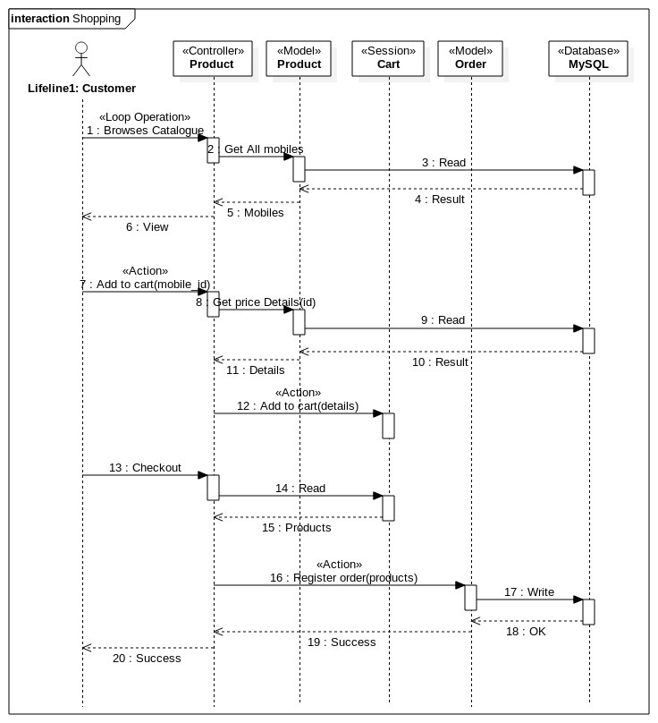**

**3.6.4 Class Diagram**

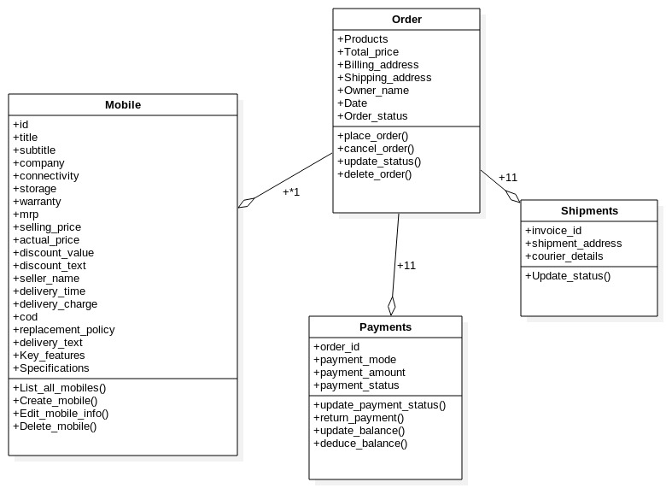**3.6.5 Component Diagram  
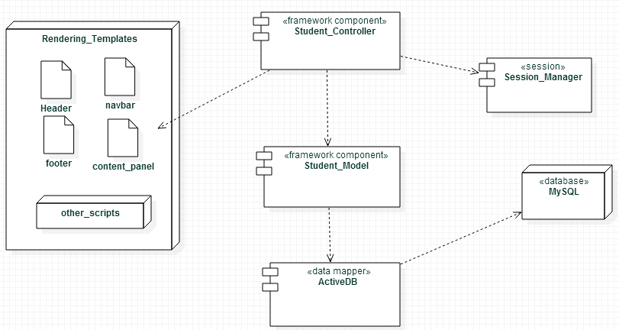**

**3.6.6 Deployment Diagram**

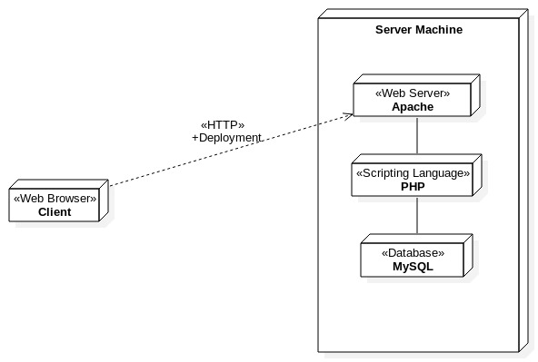

**CHAPTER 4**

**PROCESS MODEL**

Agile SDLC model is a combination of iterative and incremental process models with focus on process adaptability and customer satisfaction by rapid delivery of working software mobile.

Agile Methods break the mobile into small incremental builds. These builds are provided in iterations. Each iteration typically lasts from about one to three weeks. Every iteration involves cross functional teams working simultaneously on various areas like planning, requirements analysis, design, coding, unit testing, and acceptance testing.

At the end of the iteration a working mobile is displayed to the customer and important stakeholders.

**4.1 What is Agile?**Agile model believes that every project needs to be handled differently and the existing methods need to be tailored to best suit the project requirements. In agile the tasks are divided to time boxes (small time frames) to deliver specific features for a release.

Iterative approach is taken and working software build is delivered after each iteration. Each build is incremental in terms of features; the final build holds all the features required by the customer.

Here is a graphical illustration of the Agile Model:

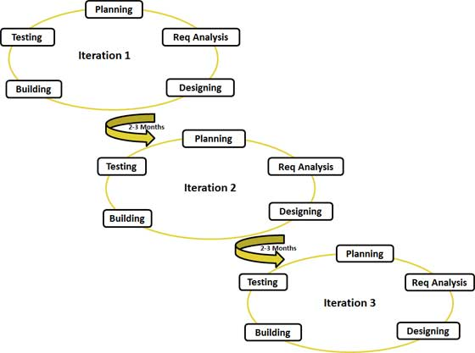

Agile thought process had started early in the software development and started becoming popular with time due to its flexibility and adaptability.

The most popular agile methods include Rational Unified Process (1994), Scrum (1995), Crystal Clear, Extreme Programming (1996), Adaptive Software Development, Feature Driven Development, and Dynamic Systems Development Method (DSDM) (1995). These are now collectively referred to as agile methodologies, after the Agile Manifesto was published in 2001.

Following are the Agile Manifesto principles

* **Individuals and interactions** - in agile development, self-organization and motivation are important, as are interactions like co-location and pair programming.
* **Working software** - Demo working software is considered the best means of communication with the customer to understand their requirement, instead of just depending on documentation.
* **Customer collaboration** - As the requirements cannot be gathered completely in the beginning of the project due to various factors, continuous customer interaction is very important to get proper mobile requirements.
* **Responding to change** - agile development is focused on quick responses to change and continuous development.

**4.2 Agile Vs Traditional SDLC Models**Agile is based on the adaptive software development methods where as the traditional SDLC models like waterfall model is based on predictive approach.  
Predictive teams in the traditional SDLC models usually work with detailed planning and have a complete forecast of the exact tasks and features to be delivered in the next few months or during the mobile life cycle. Predictive methods entirely depend on the requirement analysis and planning done in the beginning of cycle. Any changes to be incorporated go through a strict change control management and prioritization.  
Agile uses adaptive approach where there is no detailed planning and there is clarity on future tasks only in respect of what features need to be developed. There is feature driven development and the team adapts to the changing mobile requirements dynamically. The mobile is tested very frequently, through the release iterations, minimizing the risk of any major failures in future.  
Customer interaction is the backbone of Agile methodology, and open communication with minimum documentation are the typical features of Agile development environment. The agile teams work in close collaboration with each other and are most often located in the same geographical location.

**4.3 Agile Model Pros and Cons**  
Agile methods are being widely accepted in the software world recently, however, this method may not always be suitable for all mobiles. Here are some pros and cons of the agile model.  
Following table lists out the pros and cons of Agile Model:

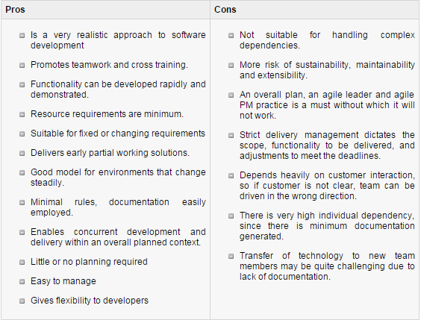

**CHAPTER 5**

**TECHNICAL DETAILS**

**5.1 Software Specification:-**

**Server:**

* Front end HTML,CSS,JavaScript
* Back end PHP,MySQL
* Database My SQL.
* Server MySQL Server,WAMP Server 5.0
* Connectivity php-mysql native connectivity

**Client:**

* A web browser should be installed to access web-application.
  1. **Hardware Specification:-**

**Client Side**

* Network Connection
* Netowork Card/Interface

**Server Side**

* 8 GB RAM (minimum).
* 500 GB Hard disk Space(minimum).
* Network Connection

**CHAPTER 6**

**TABELS AND SYSTEM DESIGN**

**6.3 Current Implementation tables  
  
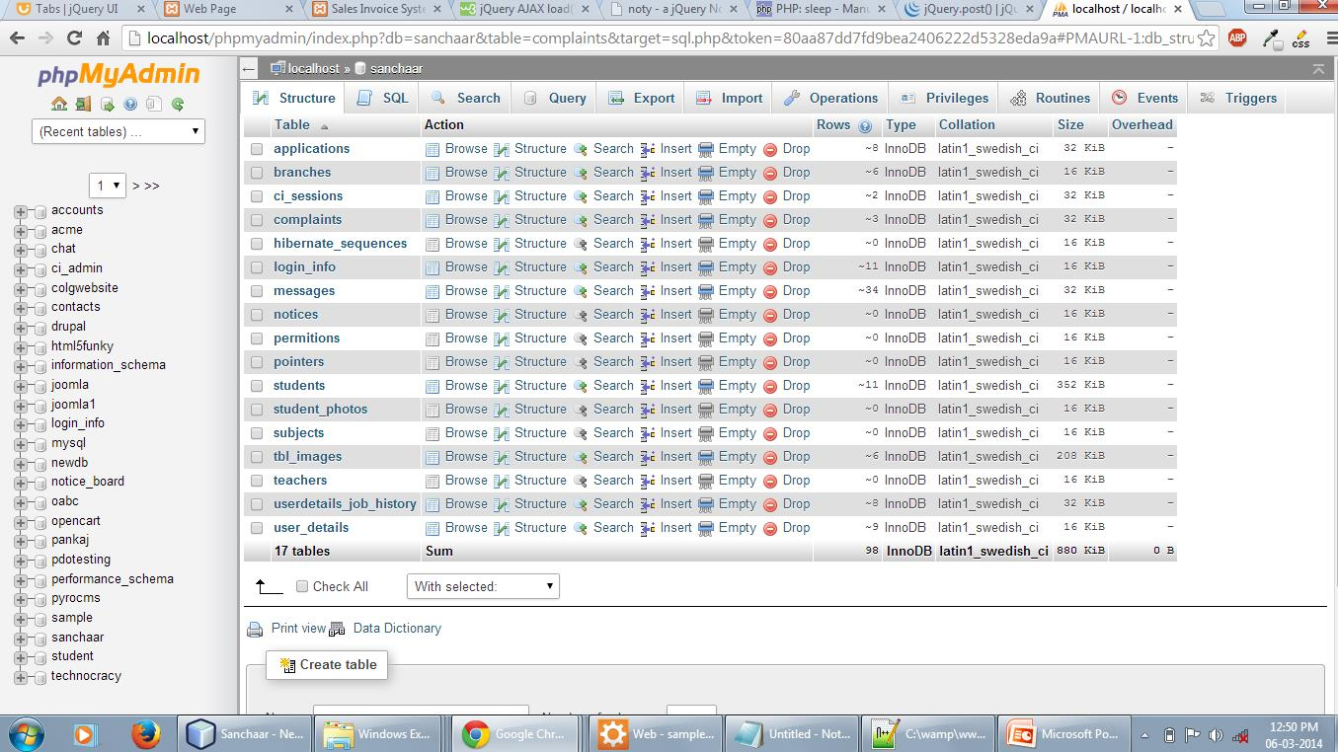**

**CHAPTER 7**

**TESTING**

* Software testing is the process of executing a program with intension of finding errors in the code.
* It is a process of evolution of system or its parts by manual or automatic means to verify that it is satisfying specified or requirements or not.
* To purpose of system testing is to check and find out the errors or faults as early as possible so losses due to it can be saved.
* Testing is the fundamental process of software success.
* Testing is not a distinct phase in system development life cycle but should be applicable throughout all phases i.e. design development and maintenance phase.
* Testing is used to show incorrectness and considered to success when an error is detected.

Different levels of testing are used in the test process; each level of testing aims to test different aspects of the system:-

The first level is **unit testing**. In this testing, individual components are tested to ensure that they operate correctly.

The second level is **integration testing**. It is a systematic technique for constructing the program structure. In this testing, many tested modules are combined into the subsystems which are then tested. The good here is to see if the modules can be integrated properly.

Third level is **systemtesting**. System testing is actually a series of different tests whose primary purpose is to fully exercise computer based system. These tests fall outside scope of software process and are not conducted solely by software engineers.

**7.1 Testing Used:-**

* White Box Testing
* Black box Testing

**7.1.1 White box testing:-** White-box testing tests internal structures or workings of a program, as opposed to the functionality exposed to the end-user. In white-box testing an internal perspective of the system, as well as programming skills, are used to design test cases. The tester chooses inputs to exercise paths through the code and determine the appropriate outputs.

While white-box testing can be applied at the unit, integration and system levels of the software testing process, it is usually done at the unit level. It can test paths within a unit, paths between units during integration, and between subsystems during a system–level test. Though this method of test design can uncover many errors or problems, it might not detect unimplemented parts of the specification or missing requirements.

**Techniques used in white-box testing include:**

* API testing (application programming interface):- testing of the application using public and private APIs.
* [Code coverage](http://en.wikipedia.org/wiki/Code_coverage):-creating tests to satisfy some criteria of code coverage (e.g., the test designer can create tests to cause all statements in the program to be executed at least once).
* [Fault injection](http://en.wikipedia.org/wiki/Fault_injection) method:- intentionally introducing faults to gauge the efficacy of testing strategies.
* [Mutation testing](http://en.wikipedia.org/wiki/Mutation_testing) methods.
* [Static testing](http://en.wikipedia.org/wiki/Static_testing) method.

**7.1.2 Black-Box Testing**:- Black-box testing treats the software as a "black box", examining functionality without any knowledge of internal implementation. The testers are only aware of what the software is supposed to do, not how it does it. Black-box testing methods include: [equivalence partitioning](http://en.wikipedia.org/wiki/Equivalence_partitioning), [boundary value analysis](http://en.wikipedia.org/wiki/Boundary_value_analysis), [all-pairs testing](http://en.wikipedia.org/wiki/All-pairs_testing), [state transition tables](http://en.wikipedia.org/wiki/State_transition_table), [decision table](http://en.wikipedia.org/wiki/Decision_table) testing, [fuzz testing](http://en.wikipedia.org/wiki/Fuzz_testing), [model-based testing](http://en.wikipedia.org/wiki/Model-based_testing), [use case](http://en.wikipedia.org/wiki/Use_case) testing, [exploratory testing](http://en.wikipedia.org/wiki/Exploratory_testing) and specification-based testing.

### 7.1.3Alpha testing:- Alpha testing is simulated or actual operational testing by potential users/customers or an independent test team at the developers' site. Alpha testing is often employed for off-the-shelf software as a form of internal acceptance testing, before the software goes to beta testing.

**7.1.4 Beta testing:-** Beta testing comes after alpha testing and can be considered a form of external [user acceptance testing](http://en.wikipedia.org/wiki/User_acceptance_testing). Versions of the software, known as [beta versions](http://en.wikipedia.org/wiki/Beta_version), are released to a limited audience outside of the programming team. The software is released to groups of people so that further testing can ensure the mobile has few faults or [bugs](http://en.wikipedia.org/wiki/Computer_bug). Sometimes, beta versions are made available to the open public to increase the [feedback](http://en.wikipedia.org/wiki/Feedback#In_organizations) field to a maximal number of future users.

**Table 2.** List of Test Cases.

Functional

Requirement No.

Test

Case

No.

Test-Case Short Description

FR01 TC01 To test the Login/Authentication interface for the Admin

TC02 To test the Login/Authentication interface for the users

FR03 TC03 To test, users can view the items they add in the shopping cart.

FR06 TC04 To test, Admin can upload new/revised categories.

TC05 To test, Admin can upload new/revised items.

FR07 TC06 To test, Admin can view all the users registered in the system

FR08 TC07 To test, Admin can view the information about all the users who

successfully placed an order.

FR09 TC08 To test that users cannot check out with an empty shopping cart.

FR10 TC09 To test that users are not able to submit an order form if the

information in any of the fields is not valid.

FR11 TC010 To test that users are not able to submit an order form if the

information in any of the fields is left blank.

**CHAPTER 8**

**SCREEN LAYOUTS**

**8.1 Mobile screen for all the views**

**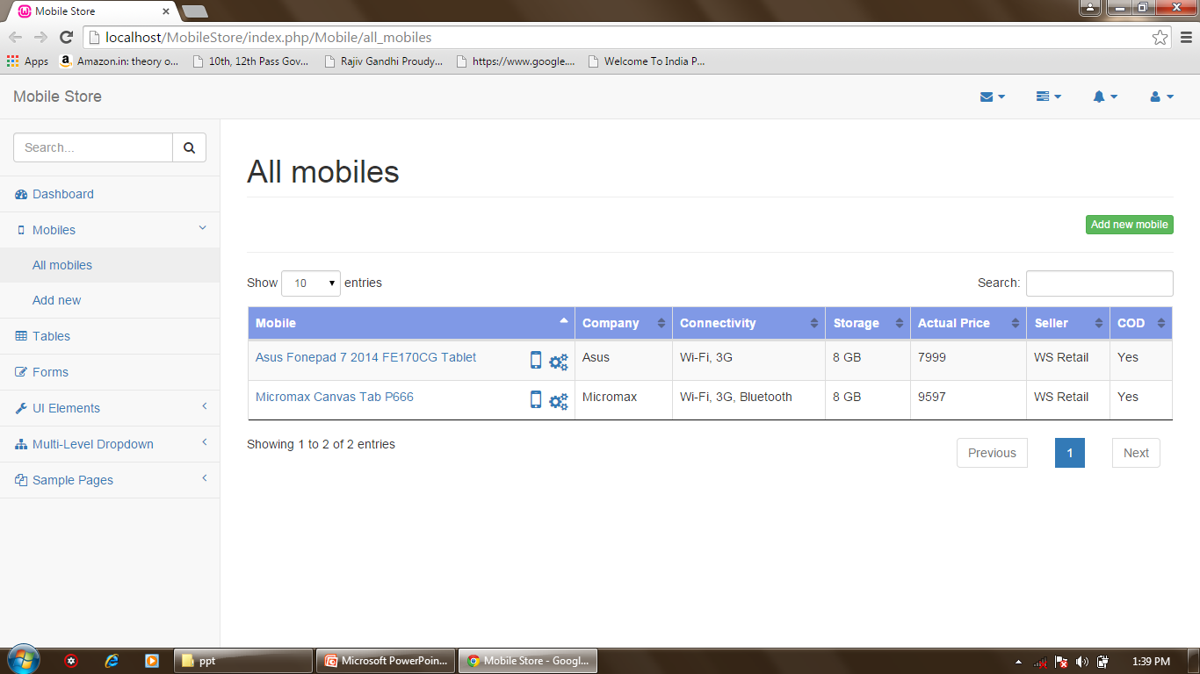  
8.2 Custumer home page   
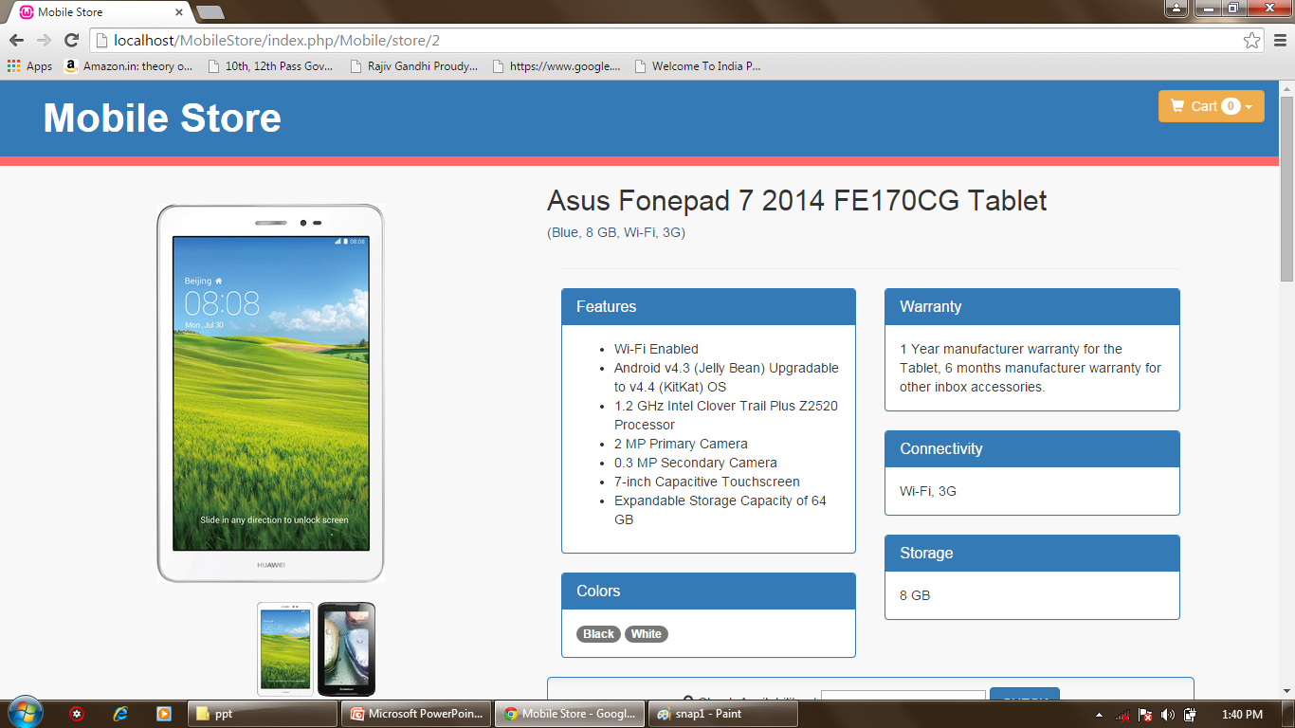**

**8.3 Admin setting page  
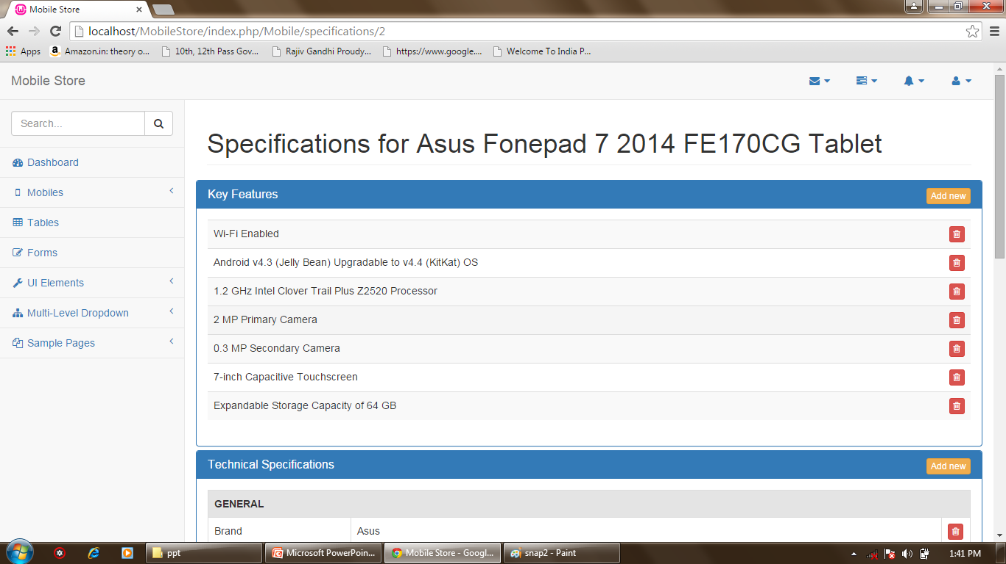**

**8.4 Add new feature   
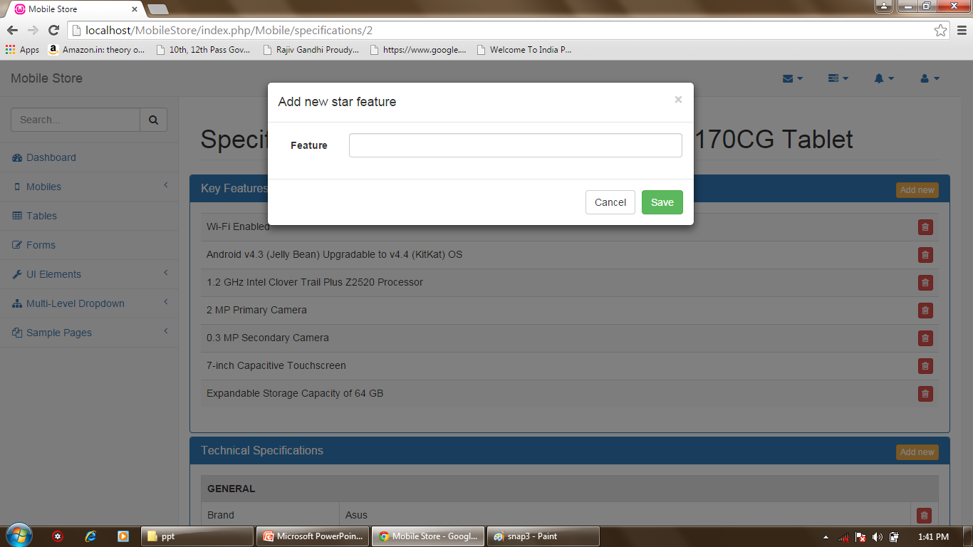**

**8.5 Add new specification  
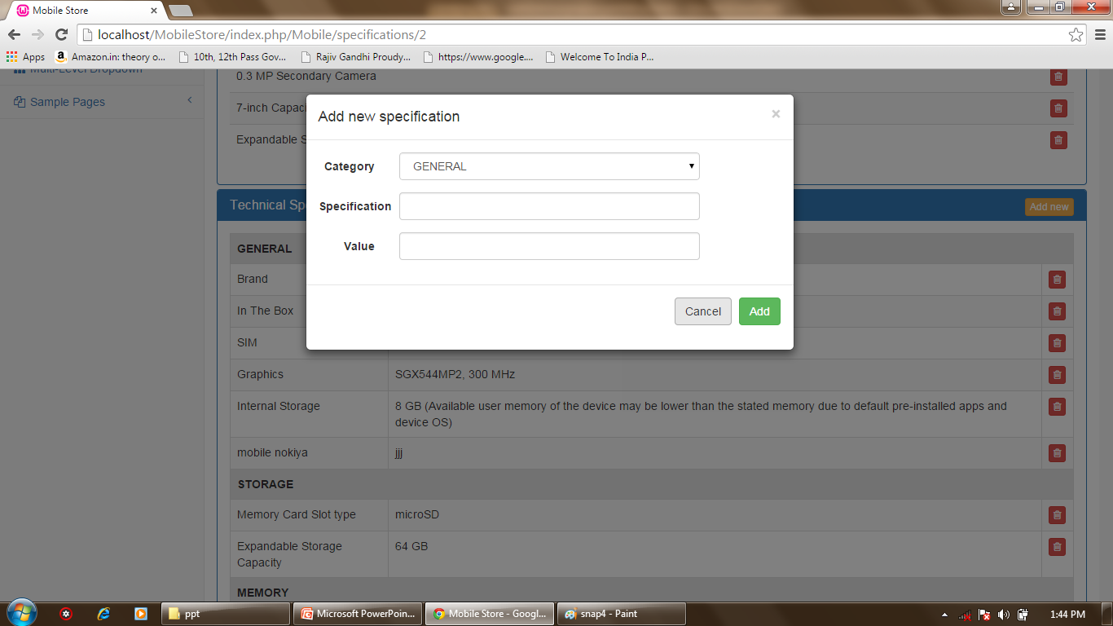**

**8.6 Add new image   
 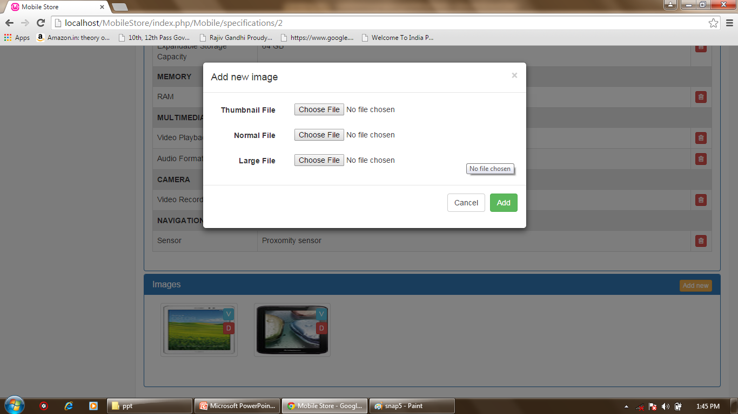**

**CHAPTER 9**

**FUTURE ENHANCEMENTS**

The following section discusses the work that will be implemented with future releases of

the software.

1. **Detailed categories:** Future work could involve adding more categories which are more

detailed and have additional items.

2. **Watch/Wish List:** Work can add a watch list or wish list so that users can add an item to a

list to watch for item prices to go down or to see when there is a sale on any of those items.

68

3. **Enhanced User Interface:** Work on enhancing the user interface by adding more user interactive

features.

4. **Recommended Items:** Add a bar that would display the most-recommended items which

would depend on the number of times an item has been purchased by any users.

5. **Payment Options:** Add different payment options, such as Visa, MasterCard, PayPal, etc.,

where a user can also save the card information for later checkouts.

6. **Shipping Options:** Add different types of shipping options: regular shipping, expedited

shipping, international shipping, etc.

7. **Recent History:** Display the user’s recently browsed items in the recent-history tab.

**CHAPTER 10**

**CONCLUSION**

* Mobile Store project provides full fledge facilities and an online simulation of shopping activities.
* It facilititates management with different product options, shopping facilities which make shopping and store management an ease.
* Compared to earlier systems MobileStore is really touhing the soul surface of online shopping , making everyting possible with its cutting edge and innovative features.
* Change is another name of improvement and MobileStore is ready to adapt any change.
* Its core features are so made that allow its extension in any way possible,from additional logins to extended polls, from rest API’s to Mobile app extension, everything can be done with MobileStore.
* With MobileStore, out goal is to provide business a complete online shopping environment where customer can reach to a wide variety of products,customer can reach to management and together we can make a healthy shopping environment where each and everyone is satisfied.
* Our effort is to minimize paper work as much as possible and we encourage business to do all its activities via MobileStore system.
* More the dependability more will the productivity of business.
* Our innovative pricing features are so made that it makes comaring and analyzing products a breeze to customers.
* We hope that mobileStore project will bring customers an amazing experiece in online shopping.

**References:**(1) PHP collection framework studied at tutorialspoint.com  
<http://www.tutorialspoint.com/php/>

(2)HTML,CSS and JavaScript   
<http://www.w3schools.com/>  
(3)TutsPlus Tutorials for Codeigniter and PHP:  
<http://tutsplus.com/>

**BIBLIOGRAPHY**

The following books were very helpful during the completion of project:

* **Software Engineering**

By Roger S.Pressman.

* **PHP Cookbook, 3rd Edition,** **Solutions & Examples for PHP Programmers** By David Sklar, Adam Trachtenberg
* **Expert PHP and MySQL, Application Design and Development**   
   By Marc Rochkind
* **CodeIgniter for Rapid PHP Application Development** By David Upton